Taking Part in a Heat and Wellbeing Project

We are inviting people with lived and living experience of a severe mental illness to take part in a project exploring how extreme heat affect people’s health and daily life. Living with a severe mental illness often includes having a diagnosis of schizophrenia, psychosis, bipolar disorder or severe depression, but might also mean you regularly see a mental health professional for a mental health condition.
We know that people with severe mental illness may face extra challenges during very hot weather. This project aims to understand why this happens and how services and communities can respond better.
We are forming a small advisory group (around 8 people) made up of people with lived experience, alongside a mental health professional and a community leader. The group will help the research team guide the project and be involved in making practical guides and recommendations.
The group will meet online about every six months. Everyone will be paid for their time, and support will be available to make it as accessible and comfortable as possible. We want to include a diverse range of voices from different communities and regions across England.
If you are interested in joining the project group, please complete the short online expression of interest form (scan the QR code with your phone camera or click this link). This helps us bring together a balanced and inclusive group.

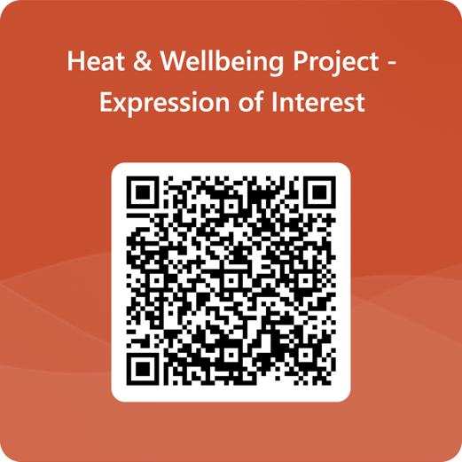
After you register, we will contact you with more information about what’s involved and next steps.
Please email p.clery@ucl.ac.uk with any questions.

