
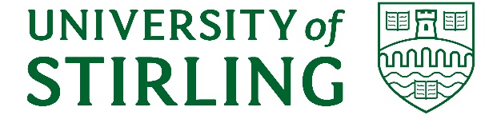
The relationship between deprivation, self-management beliefs and well-being in cancer survivors living in Scotland
Interested in taking part in research? As part of an MSc dissertation research project, I am conducting an online survey to understand the impact of deprivation on the recovery of health and wellbeing for cancer survivors. The survey will take 15-25 minutes to complete.
Who can take part?
- Adults over 18 years of age
- Currently living in Scotland
- Have completed primary cancer treatment.
This study is looking to recruit participants to fill out an online survey between the 16th of March and the 3rd of July 2026.
How to take part?
Please click on this link to the online survey:

Further Information:
Responses to the survey will be anonymous and for research purposes only. The information you provide will only be accessible to the researcher. There will be no payment for taking part in this project.
Contacts:
Theresa Campbell thc00089@students.stir.ac.uk (MSc student).
Gozde Ozakinci gozde.ozakinci@stir.ac.uk (Supervisor).
Faculty of Natural Sciences.
The ethical approaches of this project have been approved through the University of Stirling General University Ethics Panel.

