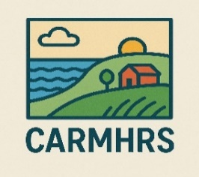
What is a LEAG?
Coastal and Rural Mental Health Realist Study (CARMHRS)
Lived Experience Advisory Group (LEAG)
What is a LEAG?

Contact Sam & Kirsty at 01752 583618 or CARMH@plymouth.ac.uk for more info.
What is the purpose of the research?
- To talk to community members, patients and service providers to understand what is being done to support mental health locally.

- To understand if existing mental health services are acceptable and accessible to the coastal and rural communities they serve.

- To understand why one service or strategy might work well in one place / for one person but might not work very well in another place / for a different person.

- To use what we learn to co-create a tailorable guide to improving coastal and rural mental health.

You can get involved in multiple* ways:
- Joining regular group meetings
- Joining regular 1-to-1 meetings
- Providing feedback by email, phone or voice note etc.

*This will depend on your preferences and the number of spaces available.
All contributions and contributors are valued.
Vouchers will be provided to re-imburse time and expenses.

.
CARMHRS is an NIHR-funded study hosted by the University of Plymouth and partner universities.
Sam and Kirsty are your Cornwall CARMHRS researchers.

How can you get involved?
A LEAG is made up of people who are experts by lived experience on a particular topic.
We are looking for people with personal experience of living with (or caring for someone living with) metal health problems and living in coastal or rural areas of Cornwall to join our LEAG.
The LEAG will meet regularly to:
1) Make sure we are asking the right questions to the right people.
2) Give feedback on our research materials and findings.
- Share what we learn along the way.
- Help us to understand what we are learning means locally.
Who are the researchers?
Have you experienced mental health difficulties?
Do you live in a coastal or rural area of Cornwall?
Yes? Then consider joining our lived experience advisory group!

What is a LEAG?

